Std Dev CI Overlay

This platform allows the user to create a plot with 3 parameters (Mean, SD and CV) with their correct CI lines. The platform is run through JSL and the default chart platform in JMP. Clicking FIVEX Tools>Std Dev Overlay in the JMP Menu will open the starting dialog. If no JMP table is open, the user will be prompted to open one.

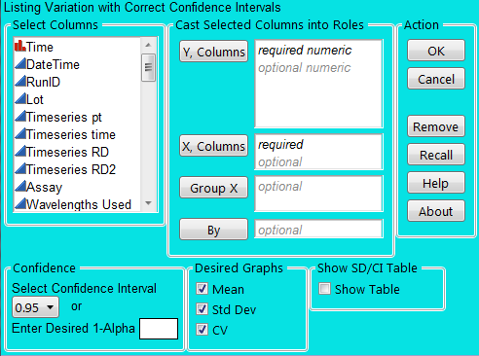
Within the dialog, the use will have several options. The columns in the table will be listed to the far left. The user will be able to move columns to three key areas: Y, Columns; X, Columns, Group X and By.

Users may adjust the confidence (dropdown or manually entering) as well as select which graphs are desired. In addition, the user may also select to show the final table used to create the graphics should further analysis be desired.

Y, Columns requires one numeric column, but the user is unlimited in how many responses can be chosen.

X, Columns requires one character column, but the user is not restricted in how many columns are chosen. The order the columns are added will directly affect the final output. (The x-axis is in a hierarchy based on column order.) Value-Ordering preferences will be maintained throughout the analysis.

Group X only allows one numeric or categorical column and allows the user to add depth to the graph without having a complex X-axis. Grouping categories will be displayed on the top of the graph rather than in the hierarchy in the X-axis.

By is optional by the user and is unlimited in number of columns added. In addition, Value-Ordering preferences will be maintained throughout the analysis.

NOTE: Column names/headers containing commas may cause problems with the script when chosen as X, Group X, or By variables.

Confidence allows the user to choose the 1-alpha level for the CI lines that are applied. There is a drop-down menu that allows the user to select from the standard levels offered by JMP

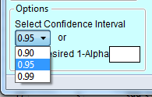
In addition, the user can manually enter a 1-Alpha level that will override the drop-down list.

Desired Graphs allows the user to choose which of the three parameters (Mean, Std Dev, or CV) is desired. Any combination of the three is supported.

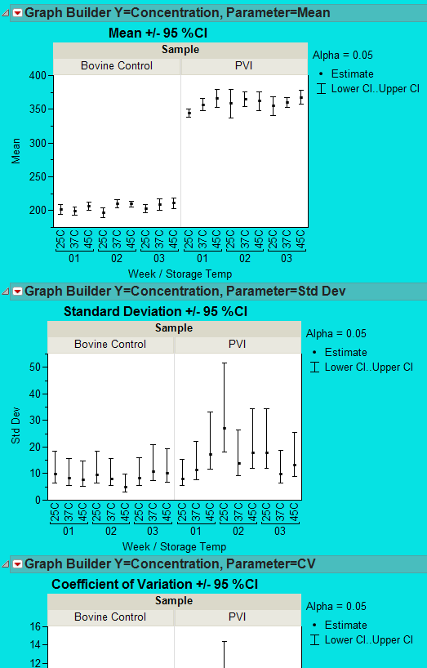
The script will create sub-tables from the original based on column selection and extract the necessary information for the final output. The final output will show graphs for Mean, SD and CV (as selected) along with CI lines in accordance with the X, Columns hierarchy and By variable selection. The Group X column is represented by Sample in the example to the left.

Estimate is the nominal value for the parameter.
Lower CI..UpperCI is the lower and upper CI for the parameter

The upper and lower CIs are calculated by JMP for Mean and SD, but CV intervals are done manually via the JSL script.

For any given grouping the CI lines for CVs are calculated as follows:
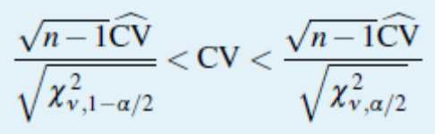

Note: Changes to default platform settings may change appearance of graphics on a user by user basis. Script was designed to work with JMP default platform settings

